#Line Plot Example
from matplotlib.pyplot import *
x = [1, 2, 3, 4, 5]
y = [2, 3, 5, 7, 11]
#start x from 1 & prime num values should match the num of ele in x
plot(x, y, label= "Prime Numbers", color="green", marker="o")
#x values in x-axis & y values in y-axis
#label and legend works as one & marker is the points in the graph
xlabel("X Axis")
ylabel("Y Axis")
title("Line Plot") #title of the graph
grid(True)
legend()
show()
Output:
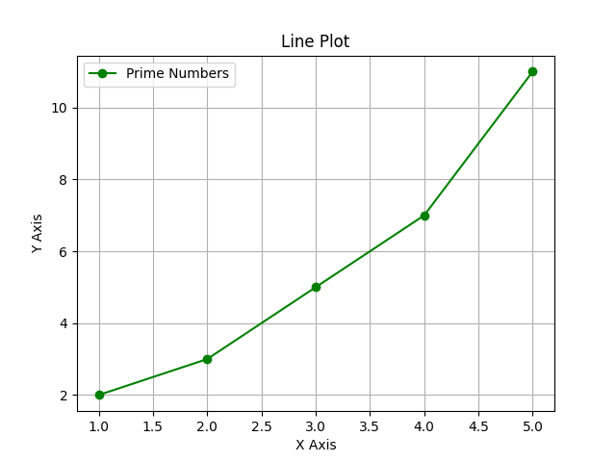
#Bar Plot Example
from matplotlib.pyplot import *
Fruits = ["Watermelon", "Orange", "Mango", "Apple", "Banana"]
Quantities = [2, 7, 10, 2, 12]
bar(Fruits, Quantities, color="green")
xlabel("Fruits")
ylabel("Quantity")
title("Bar Plot") #title of the graph
grid(True)
legend()
show()
Output:
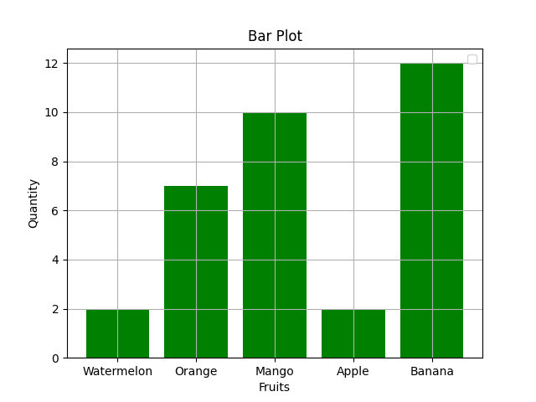
#Scatter Plot Example
from matplotlib.pyplot import *
x = [1, 2, 3, 4, 5]
y = [5, 7, 10, 2, 1]
scatter(x, y, color="red", marker="*")
xlabel("X Values")
ylabel("Y Values")
title("Scatter Plot") #title of the graph
grid(True)
legend()
show()
Output:
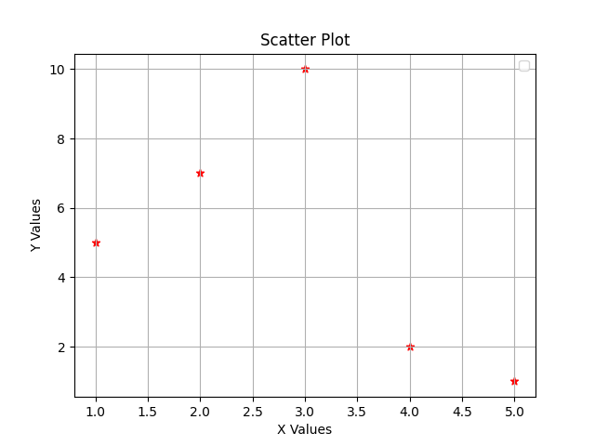
#Scatter Plot ‘Savefig’ Example
from matplotlib.pyplot import *
x = [1, 2, 3, 4, 5]
y = [5, 7, 10, 2, 1]
scatter(x, y, color="red", marker="*")
xlabel("X Values")
ylabel("Y Values")
title("Scatter Plot") #title of the graph
grid(True)
legend()
savefig("scatter_plot.png")
show()
Output:
Will save the Scatter plot in the form of an image in ‘.png’ extension.
#To Read data in a file
File: rainfall.txt
Date,Rainfall
2025-07-01,12
2025-07-02,0
2025-07-03,5
2025-07-04,20
Code to open and read the file:
# Open the file in read mode
with open('rainfall.txt', 'r') as file:
# Skip the header line
header = file.readline()
# Read each line in the file
for line in file:
# Remove trailing whitespace
line = line.strip()
# Split the line by comma
date, rainfall = line.split(',')
# Print the data
print(f"Date: {date}, Rainfall: {rainfall} mm")

Output:
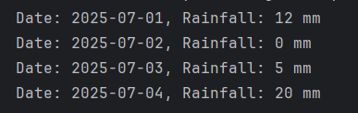

CODE:
from matplotlib.pyplot import *
with open('rainfall.txt', 'r') as file:
header = file.readline()
for line in file:
line = line.strip()
date, rainfall = line.split(',')
bar(date, rainfall, color="red")
# print(f"Date: {date}, Rainfall: {rainfall} mm")
xlabel("Date")
ylabel("Rainfall")
title("Climate")
show()

OUTPUT:
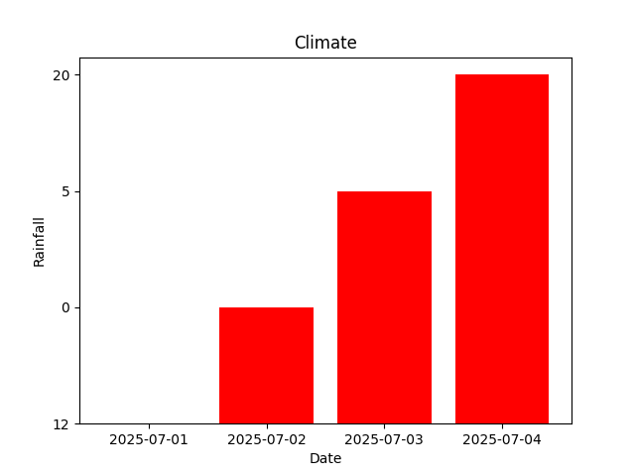

CODE:
from pandas import *
from matplotlib.pyplot import *
df = read_csv('rainfall.txt')
df_sorted = df.sort_values(by='Rainfall')
x = df_sorted['Date']
y = df_sorted['Rainfall']
bar(x, y, color = "red")
title('Climate')
xlabel('X-axis Label')
ylabel('Y-axis Label')
show()

OUTPUT:
